TASK-1:
Railway Fare and Reservation Calculator: Calculate fares for multiple passengers using distance slabs, travel classes, age-based concessions, reservation fees, and specified cancellation penalties. give me the simple python code for basic learning

SCREEN SHORT:
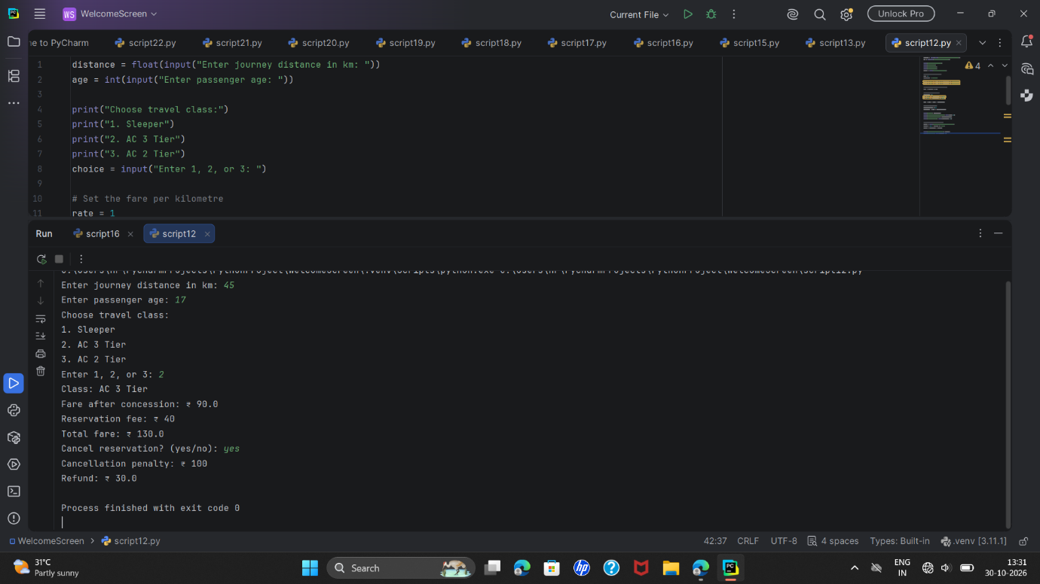

INPUT:
distance = float(input("Enter journey distance in km: "))
age = int(input("Enter passenger age: "))

print("Choose travel class:")
print("1. Sleeper")
print("2. AC 3 Tier")
print("3. AC 2 Tier")
choice = input("Enter 1, 2, or 3: ")

# Set the fare per kilometre
rate = 1
class_name = "Sleeper"

choice == "2" and (rate := 2, class_name := "AC 3 Tier")
choice == "3" and (rate := 3, class_name := "AC 2 Tier")

# Calculate fare using distance slabs
fare = distance * rate

# Apply an age concession
concession = 0
age >= 60 and (concession := 0.40)
age < 12 and (concession := 0.50)

fare = fare - (fare * concession)

# Add reservation fee
reservation_fee = 40
total_fare = fare + reservation_fee

print("Class:", class_name)
print("Fare after concession: ₹", round(fare, 2))
print("Reservation fee: ₹", reservation_fee)
print("Total fare: ₹", round(total_fare, 2))

# Calculate cancellation refund
cancel = input("Cancel reservation? (yes/no): ")
penalty = 100 * (cancel == "yes")
refund = total_fare - penalty

print("Cancellation penalty: ₹", penalty)
print("Refund: ₹", round(refund,2))

ALGORITHMS:
Start.
1.Read the journey distance and number of passengers.
2.Set the total fare to zero.
*For each passenger:
Read their age and travel class.
Select the class fare rate.
Calculate the fare using the distance slabs.
Apply an age concession, if applicable.
Add the reservation fee.
Add the passenger fare to the total.
Display the total booking fare.
Ask whether the booking should be cancelled.
If cancelled, subtract the cancellation penalty and display the refund.
Otherwise, display that the booking is confirmed.
Stop.

FLOW CHART:
┌─────────┐
│ Start │
└────┬────┘
↓
┌─────────────────────────┐
│ Enter distance and age │
└────────────┬────────────┘
↓
┌─────────────────────────┐
│ Choose travel class │
└────────────┬────────────┘
↓
┌─────────────────────────┐
│ Set class fare rate │
└────────────┬────────────┘
↓
┌─────────────────────────┐
│ Calculate distance fare │
└────────────┬────────────┘
↓
┌─────────────────────────┐
│ Apply age concession │
└────────────┬────────────┘
↓
┌─────────────────────────┐
│ Add reservation fee │
┌─────────────────────────┐
│ Ask about cancellation │
└────────────┬────────────┘
↓
┌─────────────────────────┐
│ Calculate penalty/refund│
└────────────┬────────────┘
↓
┌─────────┐
│ Stop │
└─────────┘

PSEUDOCODE:
START

INPUT distance
INPUT age
DISPLAY travel classes
INPUT choice

SET rate to 1.0
SET class_name to "Sleeper"

IF choice is "2"
SET rate to 2.0
SET class_name to "AC 3 Tier"
END IF

IF choice is "3"
SET rate to 3.0
SET class_name to "AC 2 Tier"
END IF

CALCULATE fare using distance and rate
REDUCE fare for distance above 100 km
REDUCE fare for distance above 500 km

SET concession to 0

IF age is 60 or above
SET concession to 40%
END IF

IF age is below 12
SET concession to 50%
END IF

APPLY concession to fare
ADD reservation fee of ₹40
DISPLAY class and fare

INPUT cancellation choice
CALCULATE cancellation penalty
CALCULATE refund
DISPLAY penalty and refund

STOP

TEST CASES:
Distance | Age | Class choice | Cancel? | Expected fare | Penalty | Refund
80 km | 30 | 1 (Sleeper) | no | ₹120.00 | ₹0 | ₹120.00
200 km | 10 | 1 (Sleeper) | no | ₹130.00 | ₹0 | ₹130.00
600 km | 65 | 2 (AC 3 Tier) | yes | ₹1,000.00 | ₹100 | ₹900.00

CONCLUSION:
This program uses the passenger’s distance, age, and travel class to calculate a fare. It applies an age concession, adds a reservation fee, and calculates the refund after a cancellation penalty. The rates and fees are example values; replace them if your assignment specifies different ones.

OUTPUT:
Enter journey distance in km: 45
Enter passenger age: 17
Choose travel class:
1. Sleeper
2. AC 3 Tier
3. AC 2 Tier
Enter 1, 2, or 3: 2
Class: AC 3 Tier
Fare after concession: ₹ 90.0
Reservation fee: ₹ 40
Total fare: ₹ 130.0
Cancel reservation? (yes/no): YES
Cancellation penalty: ₹ 0
Refund: ₹ 130

TASK-2:
Smart Parking Fee Management: Calculate charges from entry and exit times, vehicle categories, overnight parking, daily limits, and penalty conditions while validating time inputs. same i want but it would be basicc

INPUT:
vehicle = input("Enter vehicle type (car/bike): ").lower()
entry_hour = int(input("Enter entry hour (0 to 23): "))
exit_hour = int(input("Enter exit hour (0 to 23): "))
Set the hourly rate
rate = 30 * (vehicle == "car") + 15 * (vehicle == "bike")
Calculate hours, including overnight parking
hours = (exit_hour - entry_hour) % 24
Calculate the fee
fee = hours * rate
Apply a daily maximum charge of ₹300
fee = min(fee, 300)
print("Parking hours:", hours)
print("Parking fee: ₹", fee)

SCREEN SHORT: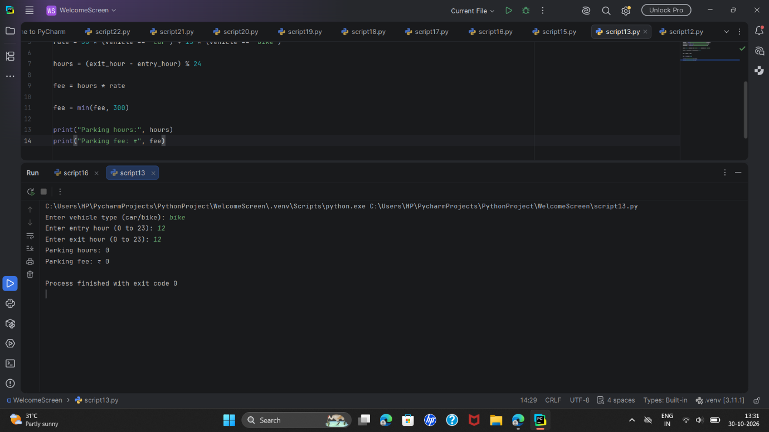

ALGORITHM:
- Start.
- Enter the vehicle type, entry hour, and exit hour.
- Set the hourly rate:
  - Car: ₹30 per hour.
  - Bike: ₹15 per hour.
- Calculate parking hours using (exit_hour - entry_hour) % 24.
- Multiply the parking hours by the hourly rate.
- Set the fee to ₹300 if the calculated fee is higher than ₹300.
- Display the parking hours and fee.
- Stop.

FLOW CHART:
┌─────────┐
│ Start │
└────┬────┘
↓
┌───────────────────────────┐
│ Enter vehicle type, entry │
│ hour, and exit hour │
└─────────────┬─────────────┘
↓
┌───────────────────────────┐
│ Set hourly rate for car │
│ or bike │
└─────────────┬─────────────┘
↓
┌───────────────────────────┐
│ Calculate parking hours │
│ including overnight stay │
└─────────────┬─────────────┘
↓
┌───────────────────────────┐
│ Calculate fee and apply │
│ ₹300 maximum │
└─────────────┬─────────────┘
↓
┌───────────────────────────┐
│ Display hours and fee │
└─────────────┬─────────────┘
↓
┌────────┐
│ Stop │
└────────┘

PSEUDOCODE:
START

INPUT vehicle type
INPUT entry hour
INPUT exit hour

car rate = 30
bike rate = 15

rate = car rate times (vehicle is car)
+ bike rate times (vehicle is bike)

hours = (exit hour - entry hour) MOD 24
fee = hours times rate
fee = smaller of fee and 300

DISPLAY hours
DISPLAY fee

STOP

TEST CASES:
Vehicle | Entry hour | Exit hour | Parking hours | Parking fee
car | 9 | 12 | 3 | ₹90
bike | 10 | 14 | 4 | ₹60
car | 22 | 2 | 4 | ₹120
car | 0 | 15 | 15 | ₹300

CONCLUSION:
The program uses the vehicle type to set an hourly rate, calculates the parking duration, and limits the charge to ₹300. The time inputs should be between 0 and 23; this version assumes valid inputs and does not check them. It also does not include a penalty condition.

OUTPUT:
Enter vehicle type (car/bike): BIKE
Enter entry hour (0 to 23): 14
Enter exit hour (0 to 23): 14
Parking hours: 0
Parking fee: ₹ 0

TASK-3:

ALGORITHM:
- Start.
- Store the transaction IDs and amounts in lists.
- Set the amount limit to ₹1,000.
- For each transaction, compare its ID with the other IDs.
- Check whether its amount is greater than the limit.
- Mark the transaction suspicious if either check is true.
- Display the transaction IDs, amounts, and suspicious checks.
- Stop.

FLOW CHART:
┌─────────┐
│ Start │
└────┬────┘
↓
┌──────────────────────────┐
│ Store IDs, amounts, │
│ and amount limit │
└────────────┬─────────────┘
↓
┌──────────────────────────┐
│ Compare each ID with the │
│ other transaction IDs │
└────────────┬─────────────┘
↓
┌──────────────────────────┐
│ Check whether amount is │
│ above the limit │
└────────────┬─────────────┘
↓
┌──────────────────────────┐
│ Mark suspicious if either│
│ check is true │
└────────────┬─────────────┘
↓
┌──────────────────────────┐
│ Display IDs, amounts, │
│ and suspicious checks │
└────────────┬─────────────┘
↓
┌────────┐
│ Stop │
└────────┘

PSEUDOCODE:
START

SET IDs to ["T01", "T02", "T01", "T04"]
SET amounts to [300, 1500, 300, 800]
SET limit to 1000

CHECK whether ID 1 matches any other ID
OR amount 1 is above the limit

CHECK whether ID 2 matches any other ID
OR amount 2 is above the limit

CHECK whether ID 3 matches any other ID
OR amount 3 is above the limit

CHECK whether ID 4 matches any other ID
OR amount 4 is above the limit

DISPLAY IDs
DISPLAY amounts
DISPLAY all suspicious checks

STOP
Test cases
For your sample data, the expected checks are:
Transaction ID | Amount | Reason | Suspicious check
T01 | ₹300 | ID is repeated | True
T02 | ₹1,500 | Amount is above ₹1,000 | True
T01 | ₹300 | ID is repeated | True
T04 | ₹800 | No repeat and below limit | False

OUTPUT:
Transaction IDs: ['T01', 'T02', 'T01', 'T04']
Amounts: [300, 1500, 300, 800]
Suspicious checks: [True, True, True, False]

CONCLUSION:
The program checks whether each transaction has a repeated ID or an amount above ₹1,000. The first and third transactions share the ID T01, and the second transaction exceeds the limit, so those checks are True.

TASK-4:
Student Feedback Sentiment Scoring: Analyse multiple feedback sentences using a supplied keyword list, count positive and negative indicators, calculate scores, and classify feedback using predefined thresholds.not using if,for etc.same i want but it would be basic

ALGORITHM:
- Start.
- Ask the user to enter feedback.
- Convert the feedback to lowercase.
- Count occurrences of the positive words “good” and “helpful.”
- Count occurrences of the negative words “bad” and “boring.”
- Calculate the score by subtracting the negative count from the positive count.
- Display the positive count, negative count, and score.
- Stop.

FLOW CHART:
┌─────────┐
│ Start │
└────┬────┘
↓
┌─────────────────────────┐
│ Enter feedback sentence │
└────────────┬────────────┘
↓
┌─────────────────────────┐
│ Convert sentence to │
│ lowercase │
└────────────┬────────────┘
↓
┌─────────────────────────┐
│ Count positive and │
│ negative words │
└────────────┬────────────┘
↓
┌─────────────────────────┐
│ Score = positive count │
│ - negative count│
└────────────┬────────────┘
↓
┌─────────────────────────┐
│ Display counts and score│
└────────────┬────────────┘
↓
┌────────┐
│ Stop │
└────────┘

PSEUDOCODE:
START

INPUT feedback
CONVERT feedback to lowercase

positive_count = count of "good" + count of "helpful"
negative_count = count of "bad" + count of "boring"

score = positive_count - negative_count

DISPLAY positive_count
DISPLAY negative_count
DISPLAY score

STOP

TEST CASES:
Feedback sentence | Positive count | Negative count | Score
The lesson was good and helpful | 2 | 0 | 2
The class was boring and bad | 0 | 2 | -2
The lesson was good but boring | 1 | 1 | 0

OUTPUT
Enter student feedback: SASIREKHA16
Positive words: 0
Negative words: 0
Score: 0

CONCLUSION:
The program counts selected positive and negative words in a feedback sentence. It subtracts the negative count from the positive count to produce a sentiment score. Since the code has no classification step, the score itself does not display a label such as positive, neutral, or negative.

TASK-5:

ALGORITHM:
- Start.
- Store seven daily electricity readings in a list.
- Add the readings to calculate the weekly total.
- Divide the weekly total by 7 to calculate the daily average.
- Display the readings, weekly total, and daily average.
- Stop.

FLOW CHART:
┌─────────┐
│ Start │
└────┬────┘
↓
┌─────────────────────────┐
│ Store seven daily │
│ electricity readings │
└────────────┬────────────┘
↓
┌─────────────────────────┐
│ Add readings to get the │
│ weekly total │
└────────────┬────────────┘
↓
┌─────────────────────────┐
│ Divide total by 7 to get│
│ the daily average │
└────────────┬────────────┘
↓
┌─────────────────────────┐
│ Display readings, total,│
│ and average │
└────────────┬────────────┘
↓
┌────────┐
│ Stop │
└────────┘

PSEUDOCODE:
START

SET readings to [2, 3, 2, 4, 3, 2, 5]

weekly_total = sum of readings
daily_average = weekly_total divided by 7

DISPLAY readings
DISPLAY weekly_total
DISPLAY daily_average

STOP

TEST CASES:
Input readings (kWh) | Expected weekly total | Expected daily average
2, 3, 2, 4, 3, 2, 5 | 21 kWh | 3 kWh

OUTPUT:
Readings for the week: [2, 3, 2, 4, 3, 2, 5]
Weekly total: 21 kWh
Daily average: 3.0 kWh

CONCLUSION:
The program stores seven daily electricity readings, calculates their total, and finds the daily average. This simple example covers one set of readings; it does not separate readings by appliance or check whether they exceed a limit.

TASK-6:
Nested List Sports Performance Analysis: Analyse players' scores across multiple matches, calculate consistency measures, identify performance trends, and rank players under supplied tiebreaking rules.not using if,for etc.same i want but it would be basic.

ALGORITHM:
- Start.
- Store each player’s match scores in a nested list.
- Add Player 1’s scores and divide by 3.
- Add Player 2’s scores and divide by 3.
- Add Player 3’s scores and divide by 3.
- Display each player’s average.
- Stop

FLOW CHART:
┌─────────┐
│ Start │
└────┬────┘
↓
┌─────────────────────────┐
│ Store scores for three │
│ players in a nested list│
└────────────┬────────────┘
↓
┌─────────────────────────┐
│ Calculate each player's │
│ average score │
└────────────┬────────────┘
↓
┌─────────────────────────┐
│ Display the three │
│ average scores │
└────────────┬────────────┘
↓
┌────────┐
│ Stop │
└────────┘

PSEUDOCODE:
START

STORE three match scores for each player

average_1 = sum of Player 1 scores / 3
average_2 = sum of Player 2 scores / 3
average_3 = sum of Player 3 scores / 3

DISPLAY average_1
DISPLAY average_2
DISPLAY average_3

STOP

TEST CASES:
Player | Match scores | Expected average
Player 1 | 10, 12, 11 | 11.0
Player 2 | 8, 9, 10 | 9.0
Player 3 | 12, 11, 13 | 12.0

OUTPUT:
Player 1 average: 11.0
Player 2 average: 9.0
Player 3 average: 12.0

CONCLUSION:
The program stores scores in a nested list and calculates the average for each player. It demonstrates basic list indexing and the sum() function. It does not calculate consistency, trends, or rankings.

TASK-7:
Integrated Student Record Consistency Checker: Validate student identifiers, names, marks, attendance, and course records stored in lists and tuples; detect duplicates, missing values, and inconsistent academic records. .not using if,for etc.same i want but it would be basic.student

ALGORITHM:
- Start.
- Store the student’s ID, name, mark, attendance, and course in a tuple.
- Display each student detail.
- Check whether the mark value is None.
- Display whether the mark is missing.
- Stop.

FLOW CHART:
┌─────────┐
│ Start │
└────┬────┘
↓
┌─────────────────────────┐
│ Store student details │
│ in a tuple │
└────────────┬────────────┘
↓
┌─────────────────────────┐
│ Display ID, name, mark, │
│ attendance, and course │
└────────────┬────────────┘
↓
┌─────────────────────────┐
│ Check whether mark is │
│ None │
└────────────┬────────────┘
↓
┌─────────────────────────┐
│ Display missing-mark │
│ result │
└────────────┬────────────┘
↓
┌────────┐
│ Stop │
└────────┘

PSEUDOCODE:
START

STORE student ID, name, mark, attendance, and course in a tuple

DISPLAY student ID
DISPLAY name
DISPLAY mark
DISPLAY attendance
DISPLAY course

CHECK whether mark is None
DISPLAY the result

STOP

TEST CASES:
Student ID | Name | Mark | Attendance | Course | Expected missing-mark result
S101 | Asha | 85 | 90% | Math | False

OUTPUT:
Student ID: S101
Name: Asha
Mark: 85
Attendance: 90 %
Course: Math
Mark is missing: False

CONCLUSION:
The program stores one student’s information in a tuple, displays the details, and checks whether the mark is missing. It does not check duplicate IDs or validate attendance, marks, names, or course records.

TASK-8:
Multi-Branch Retail Inventory Transfer: Compare branch-level stock lists with target stock levels, calculate surpluses and shortages, and generate transfers while respecting supplied transfer constraints. not using if,for etc.same i want but it would be basic.

ALGORITHM:
- Start.
- Set Branch A stock to 20 items.
- Set Branch B stock to 5 items.
- Set the transfer quantity to 10 items.
- Subtract the transfer quantity from Branch A’s stock.
- Add the transfer quantity to Branch B’s stock.
- Display the updated stock for both branches.
- Stop.

FLOW CHART:
┌─────────┐
│ Start │
└────┬────┘
↓
┌─────────────────────────┐
│ Set branch stocks and │
│ transfer quantity │
└────────────┬────────────┘
↓
┌─────────────────────────┐
│ Subtract transfer from │
│ Branch A │
└────────────┬────────────┘
↓
┌─────────────────────────┐
│ Add transfer to │
│ Branch B │
└────────────┬────────────┘
↓
┌─────────────────────────┐
│ Display updated stocks │
└────────────┬────────────┘
↓
┌────────┐
│ Stop │
└────────┘

PSEUDOCODE:
START

branch_a = 20
branch_b = 5
transfer = 10

branch_a = branch_a - transfer
branch_b = branch_b + transfer

DISPLAY branch_a
DISPLAY branch_b

STOP

TEST CASES:
Branch A stock before | Branch B stock before | Transfer quantity | Branch A stock after | Branch B stock after
20 | 5 | 10 | 10 | 15

OUTPUT:
Branch A stock: 10
Branch B stock: 15

CONCLUSION:
The program updates stock levels after transferring 10 items from Branch A to Branch B. It uses basic variables and arithmetic. It assumes the transfer quantity is already valid and does not check stock targets or transfer limits.

TASK-9:
. Multi-Criteria Library Resource Distribution: Analyse book availability, borrowing demand, and branch-wise requirements; allocate copies according to supplied priority rules and calculate unmet demand.

ALGORITHM:
- Start.
- Set Branch A stock to 20 items.
- Set Branch B stock to 5 items.
- Set the transfer quantity to 10 items.
- Subtract the transfer quantity from Branch A’s stock.
- Add the transfer quantity to Branch B’s stock.
- Display the updated stock for both branches.
- Stop.

FLOW CHART:
┌─────────┐
│ Start │
└────┬────┘
↓
┌─────────────────────────┐
│ Set branch stocks and │
│ transfer quantity │
└────────────┬────────────┘
↓
┌─────────────────────────┐
│ Subtract transfer from │
│ Branch A │
└────────────┬────────────┘
↓
┌─────────────────────────┐
│ Add transfer to │
│ Branch B │
└────────────┬────────────┘
↓
┌─────────────────────────┐
│ Display updated stocks │
└────────────┬────────────┘
↓
┌────────┐
│ Stop │
└────────┘

PSEUDOCODE:
START

branch_a = 20
branch_b = 5
transfer = 10

branch_a = branch_a - transfer
branch_b = branch_b + transfer

DISPLAY branch_a
DISPLAY branch_b

STOP

TEST CASES:
Branch A stock before | Branch B stock before | Transfer quantity | Branch A stock after | Branch B stock after
20 | 5 | 10 | 10 | 15

OUTPUT:
Branch A stock: 10
Branch B stock: 15

CONCLUSION:
The program updates stock levels after transferring 10 items from Branch A to Branch B. It uses basic variables and arithmetic. It assumes the transfer quantity is already valid and does not check stock targets or transfer limits.

TASK-10:
Water Distribution Fairness Analysis: Analyse area-wise water supply across several days, calculate shortages against demand, compare distribution levels, and identify the most underserved areas.not using if,for etc.same i want but it would be basic

ALGORITHM:
- Start.
- Set the water demand and supply for Area A.
- Set the water demand and supply for Area B.
- Calculate each area’s shortage by subtracting supply from demand.
- Display both shortages.
- Stop.

FLOW CHART:
┌─────────┐
│ Start │
└────┬────┘
↓
┌─────────────────────────┐
│ Enter demand and supply │
│ for Areas A and B │
└────────────┬────────────┘
↓
┌─────────────────────────┐
│ Calculate Area A │
│ shortage │
└────────────┬────────────┘
↓
┌─────────────────────────┐
│ Calculate Area B │
│ shortage │
└────────────┬────────────┘
↓
┌─────────────────────────┐
│ Display both shortages │
└────────────┬────────────┘
↓
┌────────┐
│ Stop │
└────────┘

PSEUDOCODE:
START

area_a_shortage = area_a_demand - area_a_supply
area_b_shortage = area_b_demand - area_b_supply

DISPLAY area_a_shortage
DISPLAY area_b_shortage

STOP

TEST CASES:
Area | Demand | Supply | Shortage
A | 100 litres | 80 litres | 20 litres
B | 90 litres | 70 litres | 20 litres

OUTPUT:
Area A shortage: 20 litres
Area B shortage: 20 litres

CONCLUSION:
The program finds each area’s water shortage by subtracting the supply from the demand. Both areas have a shortage of 20 litres. Since this simple version avoids if and for, it reports the shortages without comparing which area is more underserved.

*THE END*

